Assignment : Python programming for GUL development.

Name : K.P. Sreenath Reddy.

Register Number : 192373049.

Department : computer science engineering.

Date of submission :26/08/2024

Problem : AIR POLLUTION API

Scenario :

We are predicting future air pollution levels and analyzing historical data on air quality. Air pollution involves the presence of harmful substances in the atmosphere that can negatively impact human health, ecosystems, and the environment. Our focus is on forecasting the concentrations of pollutants such as NO2, CO2, and others.

Tasks :

1. **Forecasting Air Pollution Data**: Ensure the API includes both the Air Quality Index (AQI) and pollutant levels such as CO2, NO2, NO, O3, SO2, and PM10.
2. **Data Flow Implementation**: Model the data flow for retrieving air pollution statistics from an external API, processing the data, and presenting it to the user.
3. **Python Application**: Develop a Python application that integrates with an air pollution statistics API (e.g., for pollutants like NO2, CO, etc.) to fetch real-time air quality data.
4. **User Interaction**: Allow users to input a region (such as a country, state, or city) and display the corresponding air pollution statistics based on their input.

Deliverables :

**Data Flow Diagram:** Provide a diagram showing how the application interacts with the API, including data retrieval and user interface components.

**Pseudocode and Implementation:** Present the pseudocode and the actual code implementation for integrating with the air pollution API and handling data.

**API Integration Documentation:** Document the integration process, detailing the methods used to fetch air pollution data from the API and how this data is presented to users.

**Assumptions and Potential Enhancements:** Outline any assumptions made during development and suggest possible improvements for optimizing the application or expanding its functionality.

Solution :

Real time forecasting air pollution

To effectively reduce Air Quality Index (API) levels, a multi-pronged approach is necessary. This includes enforcing stricter emission regulations for industries and vehicles, enhancing public transportation, and expanding green spaces to absorb pollutants. Additionally, promoting cleaner technologies and encouraging public awareness about reducing vehicle use can significantly lower pollution levels. Government initiatives, such as financial incentives and investment in research, along with protective health measures, are also crucial in improving air quality and safeguarding public health.

1.Data flow diagram

**Start**

**Measure Polluttants**

**Calculate API**

**Determine Category**

**Report AQI**

**Assess Health Impact**

2.Implementation :

import requests

def get_air_pollution_data(api_key, lat, lon):

url = f"http://api.openweathermap.org/data/2.5/air_pollution?lat={lat}&lon={lon}&appid={api_key}"

response = requests.get(url)

if response.status_code == 200:

data = response.json()

aqi = data['list'][0]['main']['aqi']

components = data['list'][0]['components']

print("Air Quality Index (AQI):", aqi)

print("Concentration of pollutants in μg/m³:")

print("CO:", components['co'])

print("NO:", components['no'])

print("NO2:", components['no2'])

print("O3:", components['o3'])

print("SO2:", components['so2'])

print("PM2.5:", components['pm2_5'])

print("PM10:", components['pm10'])

print("NH3:", components['nh3'])

else:

print("Failed to retrieve data. HTTP Status code:", response.status_code)

if _name_ == "_main_":

api_key = "7388dca5f7653c38ee1f85baa3f7a900"

lat = float(input("Enter latitude: "))

lon = float(input("Enter longitude: "))

get_air_pollution_data(api_key, lat, lon)

3.Display the current information :

Enter latitude :40.7128

Enter longitude :-74.0060

4.User input :

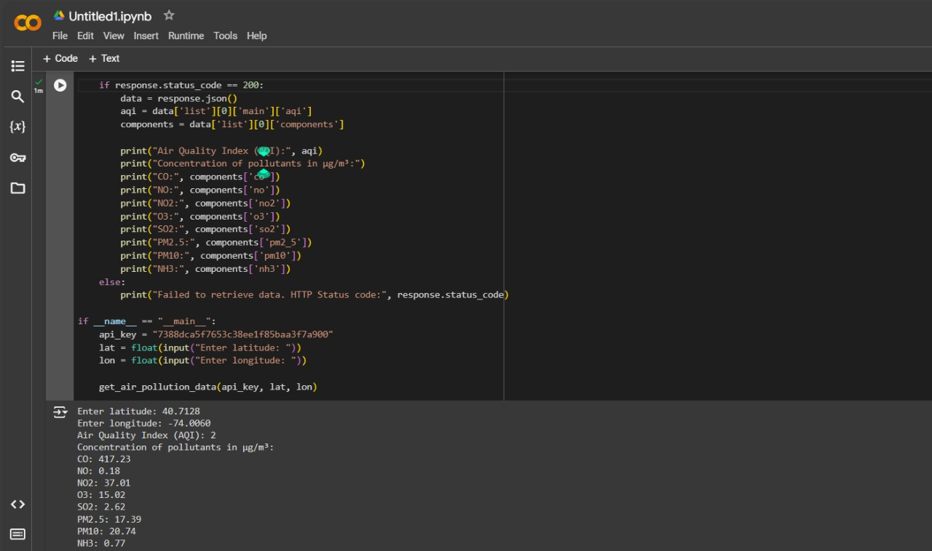

5.Documentation :

Air pollution concentration indicates the level of specific pollutants in the air at a given location and time, typically measured in units such as micrograms per cubic meter (µg/m³) for particulate matter or parts per million (ppm) for gases. Below is a comprehensive overview of key concepts and documentation relevant to air pollution:

1. **Types of Pollutants:**
   * **Particulate Matter (PM):** Includes PM2.5 (particles with a diameter less than 2.5 micrometers) and PM10 (particles with a diameter less than 10 micrometers).
   * **Gaseous Pollutants:**
     + Ozone (O₃)
     + Nitrogen Dioxide (NO₂)
     + Sulfur Dioxide (SO₂)
     + Carbon Monoxide (CO)
     + Volatile Organic Compounds (VOCs)
2. **Measurement Methods:**
   * **Gravimetric Method:** Collects particulate matter on filters and measures the mass to determine concentration.
   * **Continuous Monitoring:** Employs sensors and analyzers for real-time measurement of gaseous pollutants like O₃, NO₂, and CO.
3. **Regulatory Standards:**
   * **World Health Organization (WHO) Guidelines:** Sets international standards for air quality to protect public health.
   * **National Ambient Air Quality Standards (NAAQS):** Established by the U.S. Environmental Protection Agency (EPA) for major pollutants.
   * **European Union (EU) Air Quality Standards:** Defines limits on pollutant concentrations to safeguard human health and the environment.
4. **Data Representation:**
   * **Concentration Data:** Presented as averages over specific time periods (e.g., hourly, daily, annually).
   * **Air Quality Index (AQI):** Converts pollutant concentrations into a standardized index reflecting health risk levels.
5. **Sources of Pollution:**
   * **Natural Sources:** Includes wildfires, volcanic eruptions, and dust storms.
   * **Anthropogenic Sources:** Includes emissions from vehicles, industrial processes, agricultural activities, and residential heating.
6. **Health and Environmental Impact:**
   * **Short-term Effects:** Includes respiratory issues, cardiovascular problems, and irritation of the eyes and throat.
   * **Long-term Effects:** Includes chronic respiratory diseases, lung cancer, and cardiovascular diseases.
   * **Environmental Effects:** Includes acid rain, nutrient pollution leading to eutrophication, and damage to ecosystems.
7. **Monitoring Networks:**
   * **Government Agencies:** National bodies monitor air quality (e.g., EPA in the U.S., DEFRA in the UK).
   * **International Networks:** Organizations like the European Environment Agency (EEA) and the United Nations Environment Programme (UNEP) provide global air quality data and standards.
8. **Data Collection and Reporting:**
   * **Stationary Monitoring Stations:** Fixed locations that continuously measure air pollution.
   * **Mobile Monitoring:** Vehicles equipped with sensors for measuring pollutants in various locations.
   * **Remote Sensing:** Satellites and aerial platforms measure air pollution on a large scale.
   * **Public Access:** Real-time air quality data is often available through government websites and mobile applications.
9. **Mitigation and Control Measures:**
   * **Emission Reduction:** Adoption of cleaner technologies and stricter regulations on emissions.
   * **Urban Planning:** Designing urban areas to reduce traffic congestion and increase green spaces.
10. **Research and Development:**
    * **Pollution Modeling:** Utilizes computer models to forecast pollution levels and identify pollution sources.
    * **Health Studies:** Investigates the health impacts associated with exposure to different pollutants.
    * **Innovative Technologies:** Develops new methods for monitoring air quality and controlling pollution.

**Key References:**

* WHO Air Quality Guidelines: Global Update 2021.
* EPA Air Quality Criteria for Particulate Matter: U.S. EPA, 2019.
* European Environment Agency (EEA) Air Quality Reports: Latest annual assessments on air quality in Europe.

Graph :

